**Pavasaris**

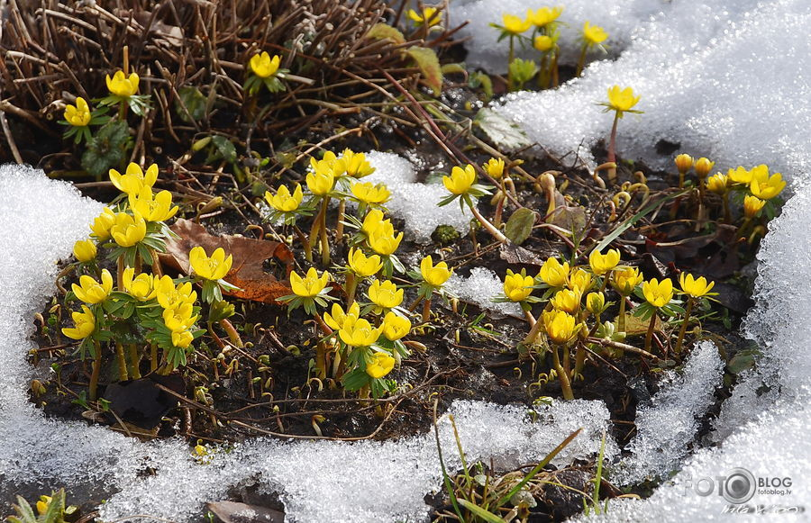

**Vasara**

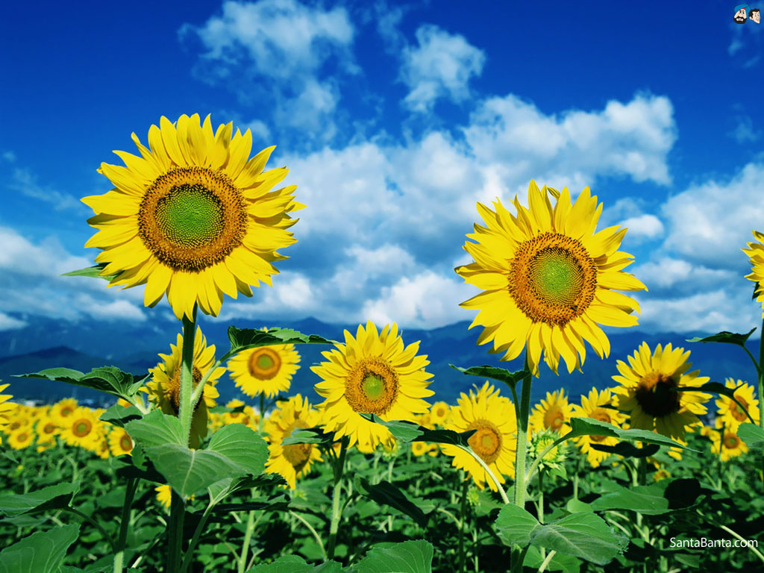

**Rudens**



**Ziema**



**Gads**

**Gadalaiki**

**Marts**

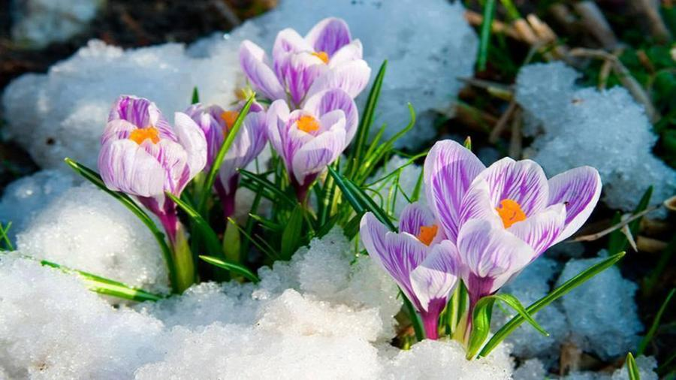

**Aprīlis**

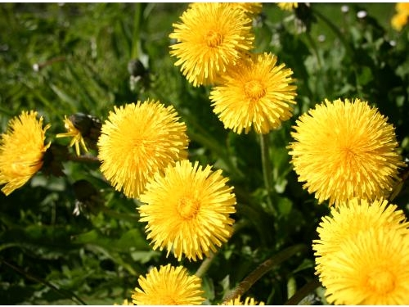

**Maijs**

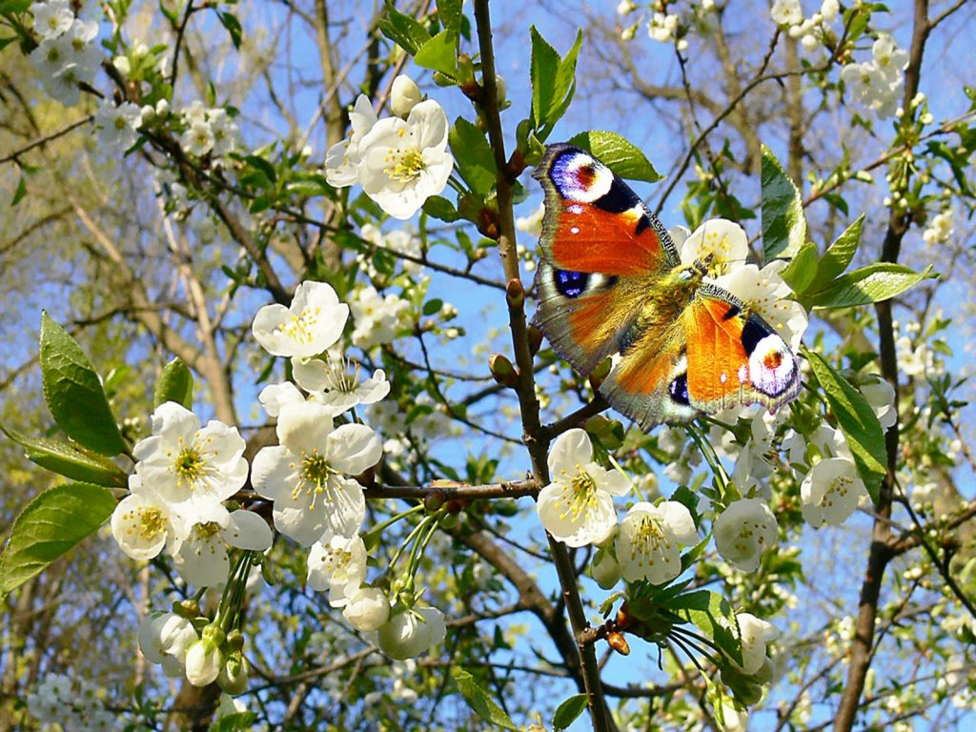

**Jūnijs**



**Jūlijs**

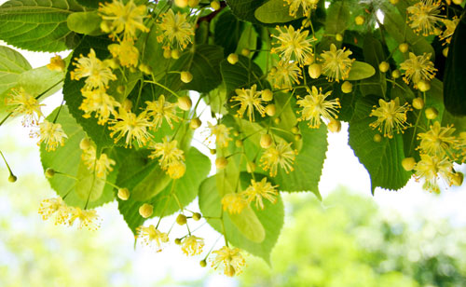

**Augusts**



**Septembris**

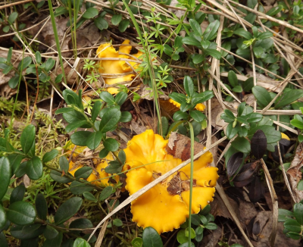

**Oktobris**

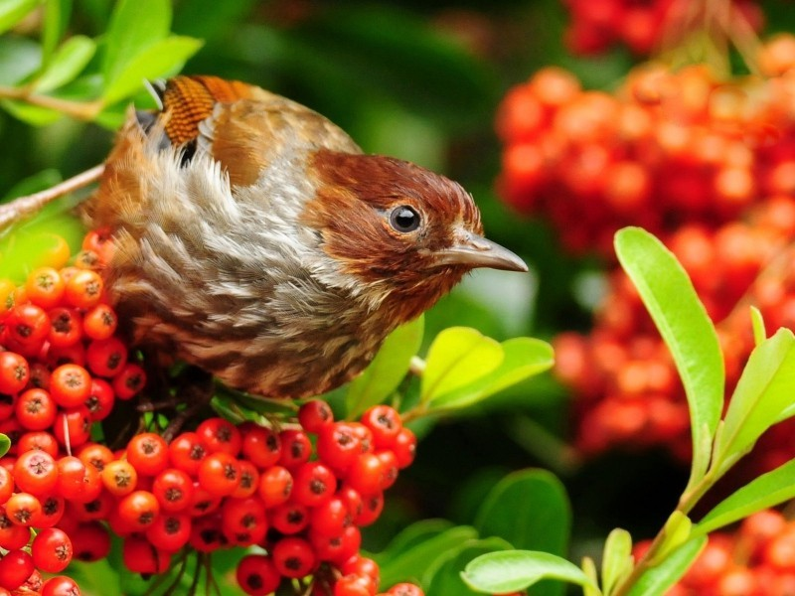

**Novembris**

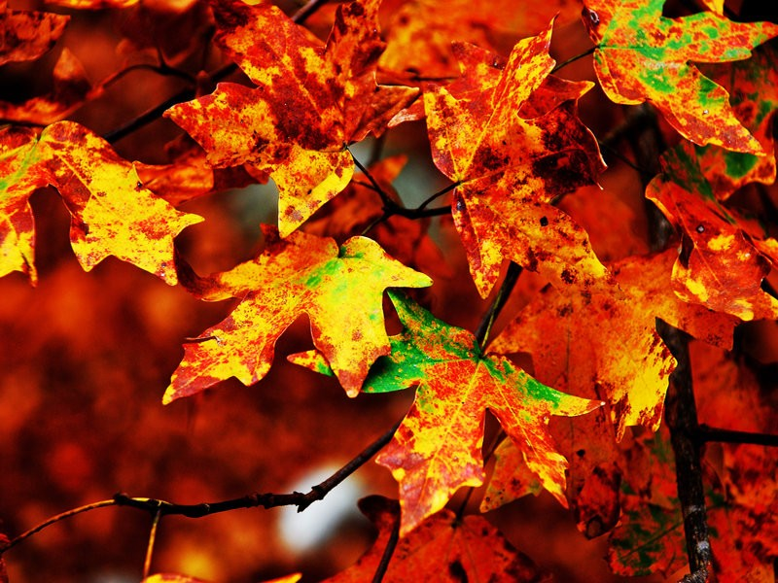

**Decembris**

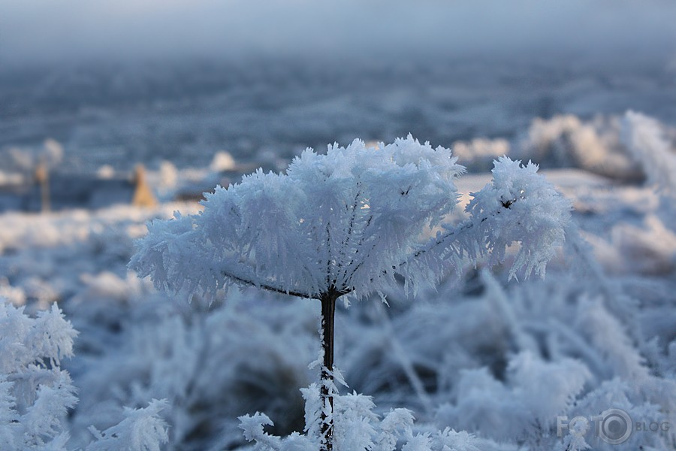

**Janvāris**

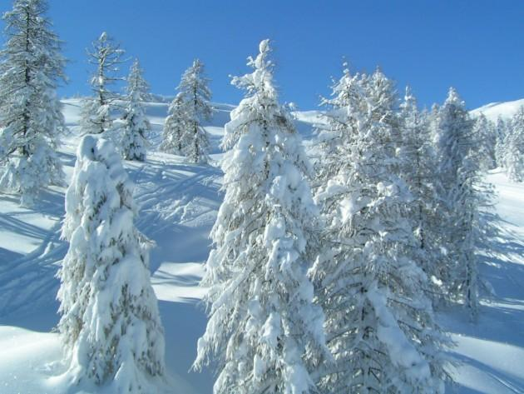

**Februāris**

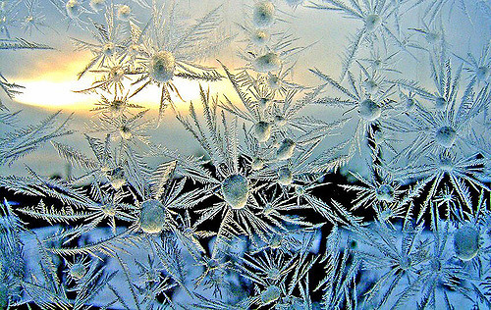

|  |  |  |
| --- | --- | --- |
| **PA** | **VA** | **SA** |
| **RIS** |

|  |  |
| --- | --- |
| **RU** | **DENS** |

|  |  |
| --- | --- |
| **ZIE** | **MA** |

|  |  |  |
| --- | --- | --- |
|  | **VA** | **SA** |
| **RA** |  |  |